**Team Assignment Section 2**

1. = β0 + β1 MktRF + β2 SMB + β3 HML

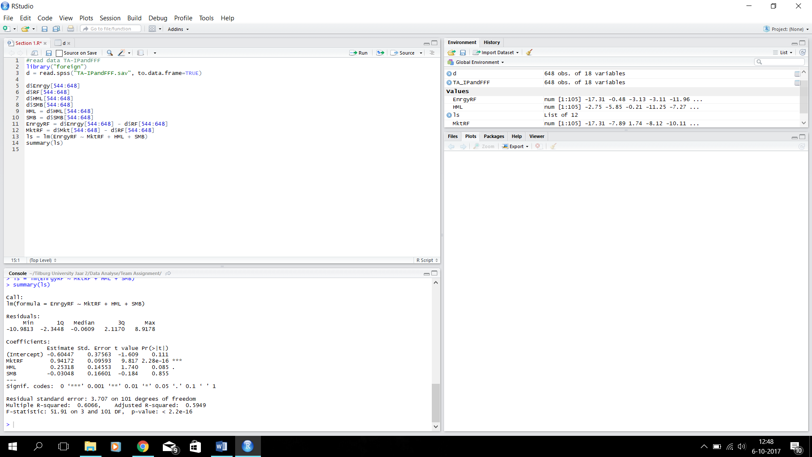

1. = -0.60447 + 0.94172 MktRF – 0.03048 SMB + 0.25318 HML

|  |  |  |  |  |  |  |
| --- | --- | --- | --- | --- | --- | --- |
|  | **H0** | **H1** | **Type Test** | **Val** | **Pval** | **Conclusion** |
| **Is the model useful?** | β1 = β2 = β3 = 0 | Not H0 | F-test | α = 0.10 | <2.2e-16 | Pvalue is smaller than alpha, so we reject H0. The model is useful |

1. MktRf is the most useful variable in the model, since it’s Pvalue is the smallest. It has a value of: 2.28e-16. HML is quite useful, because it has a value of: 0.085, and this is still a bit smaller than our alpha. SMB is not very useful, because the Pvalue is: 0.855. This is a lot bigger than the alpha.

|  |  |  |  |  |  |  |
| --- | --- | --- | --- | --- | --- | --- |
|  | **H0** | **H1** | **Type Test** | **Val** | **RR** | **Conclusion** |
| **Is SMB useful?** | β2 = 0 | Not H0 | T-test | -0.184 | 1.660081 < val <  -1.660081 | The T-value isn’t in the rejection region, so we do not reject H0. So SMB is |

|  |  |  |  |  |  |  |
| --- | --- | --- | --- | --- | --- | --- |
|  | **H0** | **H1** | **Type Test** | **Val** | **RR** | **Conclusion** |
| **Is the Three Factor Model useful?** | β1 = β2 = β3 = 0 | Not H0 | F-test | -0.184 | 1.660081 < val <  -1.660081 | The T-value isn’t in the rejection region, so we do not reject H0. So SMB is |